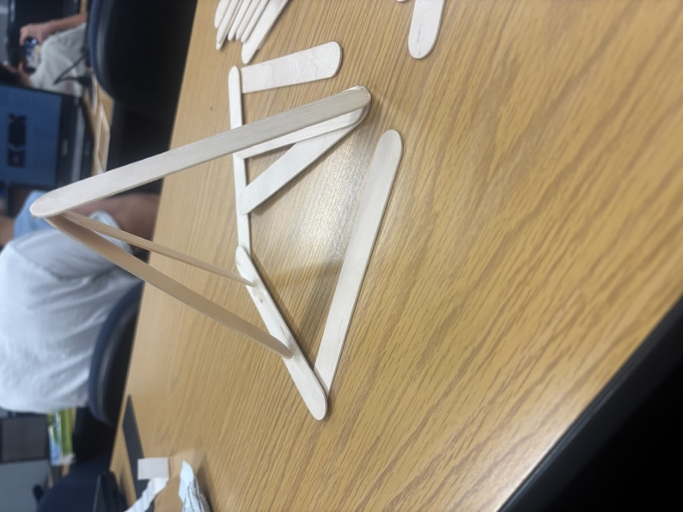

- How hard was it to build something without any requirements?
It was very hard to build something without any requirements as we didn’t know the criteria or what was considered a “successful” build. It was also hard because realistically, we could have built anything we felt like building to satisfy the only “build something” requirement we received.
- How did you feel when you found out the requirements after the build?
When I found out about the actual requirements after the build, I felt relieved that my build did pass. However, I did feel like it was all based on luck since there were no additional requirements whatsoever and I did not even know why or how it passed.

